Analyzing Social Media Tweets with SAS®
Sy Truong, Meta-Xceed, Inc. (MXI), Fremont, CA

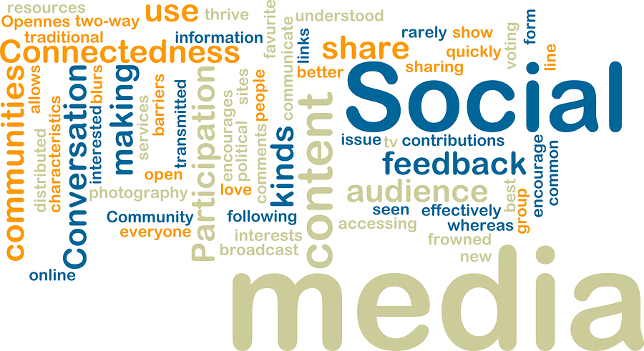
ABSTRACT
The library of congress is archiving all Twitter messages since the messages posted capture the most unfiltered and immediate opinions representing the ethos of popular culture. The information posted on Twitter expresses the most up to date pulse on a large range of topics and is a powerful research tool. With several billion messages posted since 2006 along with constant new posts; this creates challenges in finding the information matching your particular interest. This paper describes techniques on how SAS macros is used to analyze the messages or tweets that you posted and compares it with all other posts. It describes how PROC CLUSTER is used along with other SAS logic to find the best correlation of ideas and topics that are of similar interest. It then presents this recommended feed to you. The analysis of SAS goes beyond an individual ability to manually search since the criteria are constantly updated with what you post and what you decide to read from the recommended feeds. Similar to how Amazon.com recommends a book or CD based upon purchase patterns, this paper presents a method analyzes your interest through your social media messages. It then recommends others to you based on similarities in topic and content.
Introduction
Social media consists of messages from users within virtual communities shared amongst each other. At first glance, the messages appear to be insignificant since they are short, filled with commentary and links to other messages or websites. To the uninitiated, this seems to be trivial teenage chatter including absorbed conceited individual declarations about what they had for lunch. Old media requires a voice that has gravitas and authority such as the New York Times or CNN. This media landscape was caught by surprise by the rise in popularity of new media which consist of personal, individualized communication that has old media scrambling trying to recapture their audience. What old media initially perceived to be insignificant noise has crescendo into a force that displace the economics of advertising as marketing of products and services are shifting focus to user reviews rather than the traditional broad catch all commercials or newspaper advertisements. Besides advertising, social media also can deliver breaking news as messages are sent directly from cell phones rather than broadcast network television or newspapers. Social Media is encroaching upon a wide spectrum of content ranging from entertainment, news to advertisement. Traditional media is being augmented if not replaced by social media as this new media is capturing more people’s attention and time beyond even the use of search and email on the Internet.

Social media relies on a couple of constructs that has only recently come to being within the Internet age. They appear to be on opposite ends of the spectrum including the “Wisdom of Crowds” and the “Long Tail”. Both of these forces complements each other in validating and ensuring the value of the content that social media is churning out. James Surowiecki wrote the book entitled "The Wisdom of Crowds: Why the Many Are Smarter Than the Few and How Collective Wisdom Shapes Business". His book argues how the opinions of many as it is aggregated can lead to a higher accurate representation of the truth as compared to an individual opinion. An example of this is if a crowd of people are at a fair and there was a jar of jelly beans that was fairly large filled to the top. People of all ages at the fair would take a guess as to how many beans are in the jar. Some guess are too low while others overshot their estimates. However, if the average of all the guesses were tabulated, it would be the most accurate proving his concept of wisdom of crowds. His examples are primarily illustrated within economics and psychology but it can also be extended into how the opinion of many expressing ideas on social media leads to accurate information. Some examples include the dissemination of news or product reviews.

Another phenomenon that existed for a while but became popularized when Chris Anderson wrote an article on Wired magazine describing how the Internet has allowed merchants such as Amazon.com and Netflix to provide many niche products that only a few people would buy. Since the Internet could provide a virtual warehouse of products that is more efficient and larger than traditional brick and mortar stores; little unknown books, movies and music can be sold more efficiently. Anderson argues that the many specialized products if graphed would show a very long tail. The long tail when added up becomes very profitable and larger than the “head” of the distribution curve. He argues that the days of the blockbuster artist like Michael Jackson or Modanna no longer be as profitable today as compared to the 80s since consumers can now easily find esoteric artists that before would not have any audience. This principle can also apply to social media in the same way that consumers are no longer limited to three television networks or a couple of news papers but hundreds of thousands of blogs, Facebook and twitter messages discussing a wide varied set of topics.

Social media is also different in that it is interactive allowing individuals to produce and consume information in a way that was not available before. The deluge of information has prompted smart social media users to aggregate and get to the information that contains the most meaning to them as described in the Wisdom of Crowds. The abundant of different information sources that was not available before has transformed information into many distinct customized feeds for many individualized tastes and niches. This distribution of information among many distinct social networks is what leads to the long tail affect. The Long Tail has a democratizing affect on information as it allows individuals to rival and replace traditional reporters of traditional media outlets. The combination of the Wisdom of Crowds and the Long Tail which I will refer to as the “Wise Tail” is a perfect storm combining and enabling an efficient dissemination and consuming of information culminating in a new form of media that is more valuable to users compared to old media. Social media consumer can now arm themselves with tools to navigate the information finding the “channels” that contains the most pertinent and meaning to them while also allowing them to interactively expressing their opinion and ideas to a community that is receptive. This paper describes how SAS can empower the “Wise Tail” by analyzing social media content and making “Wisdom of Crowds” suggestions on all topics within the Long Tail of the Internet.
SAS Macros for Social Media Analysis
SAS has many powerful analytical tools along with a large array of methods to tapping into the power of SAS to analyze social media content. SAS is releasing a new software product referred to as “SAS Social Media Analytics” which does a great job at analyzing the semantics of social media content to determine if people are saying positive or negative things about a particular product or brand. It uses social media content in a very different way than what this paper will be demonstrating. This paper will use SAS to aggregate social media content for the purpose of individual consumption rather than having it monitor a brand or advertisement campaign for a business of advertisement campaign. The examples illustrated uses SAS macros rather than applying SAS Social Media Analytics package.

There are user friendly utilities to help analyze text such as using JMP or EG (Enterprise Guide) to assist in developing the logic for social analysis. Upon review, I found that the most flexible and direct way to get to the full power of the SAS system for a very specific need such as analyzing social media content; I used data step, some SCL and encapsulate this with a SAS macro as a form of an API (Application Programmer’s Interface) in order to easily utilize these tools repeatedly in flexible way. The macros used in this project include:
- %twituser - Capture all the twitter messages from specified user.
- %twitsearch - Search for the twitter messages with specific criteria.
- %twitlike - Recommends twitter messages that are similar or like the ones from the user specified.

The macro names start with the word “twit” which is referencing the fact that it is accessing twitter messages. This is one social media outlet but the same tools can be extended to Facebook and other social media sites as well. The macros will be used by logic on the server which can be extended to a web front end. The development of a social media website will be referenced but is beyond the scope of this paper. The description of how the social media content is captured, analyzed and then aggregated into recommendations is what will be covered from these macros. The macros can be applied in three steps.

STEP 1 – Capture User Messages
The first step in making sense out of the Twitersphere or world of social media is to understand what messages you have sent out. The messages you have created either through your cell phone or on various twitter clients such as that from a web browser, are stored on the Twitter website within your own profile. The goal is to gather and have a collection of the most recent messages you sent out in order to then find others like minded messages to then be recommended for further reading. This is accomplished through a macro named %twituser which has the following parameters.

%twituser (user = twitter user name,
outfile = output report);
Where | Is Type... | And Represents...
user | C (200 chars) | The user name for the twitter account. An example is: sytruongus
outfile | C (200 chars) | The output HTML report listing out all the tweet findings from the specified user. This includes full path with file name. If none is specified, it is defaulted to the current path with file name:  twituser.html  An example would be:  c:\mypath\sytruongus.html
This macro will use the twitter API and captures the latest twitter messages from the specified user. The information is stored in a dataset for further analysis and an HTML report is also generated as shown here.

[display of output]
….

STEP 2 – Search
Once a collection of all the latest messages from the current user has been captured, the next step is to search what other messages exist on twitter that are similar to the current user. The twitter engine provides an API that allows a SAS program or other external tools to perform a search upon specific conditions on twitter and return all message that meets the search criteria. You can perform this interactively if you were to go to the website: http://search.twitter.com. The advance option describes some of parameters you can specify in your search.

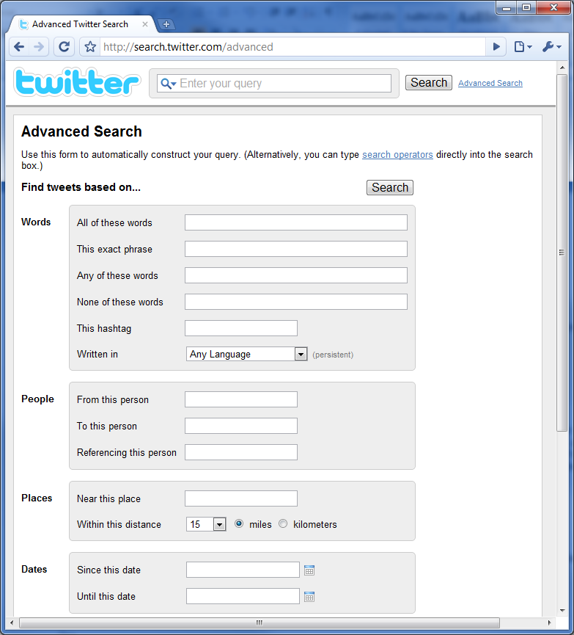

The following four options are normally applied during a search.
- Key Words – By analyzing what the currently user most commonly wrote about using PROC FREQ, you can then apply a search to identify other discussion containing these key words.
- Language – In this example, English is used since without this filter, there are many messages that may contain the same keywords but is indecipherable since social media is truly a global phenomenon.
- From this Person – A filter is applied to not include the current user in the search result. This is because the goal is to find messages from other users of similar interest excluding the current user.
- Dates – This can be adjusted depending on how many results are returned. If the topic and search criteria are so esoteric that only a small amount of results are found, the dates can be extended but by default, the search is within the current week.
There are many other conditions that are applied within the SAS program logic to decipher and analyze what is a meaningful message but it is nice to have some of the stipulations applied right up front with the search engine provided from Twitter. This helps narrow down the results so the starting point of analysis is more focused.

A search is applied through a macro named %TWITSEARH. This is the API for SAS programmers which sit on top of the twitter search.

%twitsearch (criteria = words search criteria,
user = from this user,
date = since this date,
outfile = output report);
Where | Is Type... | And represents...
criteria | C (80 chars) | The search text criteria to be applied to http://search.twitter.com. This can be one or more words. This is applied case insensitive.
user | C (200 chars)  Optional | A valid twitter user name that the search can be applied to.
date | C (10 chars) Optional | The date in which the search results will be filtered to include. The format is yyyy-mm-dd. An example is: 2010-05-14
outfile | C (200 chars) | The output HTML report listing out all the search results. This includes full path with file name. If none is specified, it is defaulted to the current path with file name:  twitsearch.html  An example would be:  c:\mypath\sytruongus.html

The search results are stored in a SAS dataset. An HTML report is also produced as shown here.
[HTML Report from macro…]

STEP 3 – Identify Similar or Like
Capturing the user messages and then applying searches are straight forward tasks that can be applied by any other programming language or tools other than SAS. Where SAS provides tools that other cannot is the ability to analyze the text and figure out how similar they are based upon various statistical models. In this example, PROC CLUSTER is used to analyze the text by placing the text into clusters and then finding out their relative distances in order to identify messages that are similar. The macro that is used to identify these like minds type of messages are applied through a macro named %TWITLIKE. This macro contains logic that uses the other two macros in order to find the relevant information. The parameters are therefore simplified to only contain the essential parameters.

%twitlike (user = twitter user name,
outfile = output report);
Where | Is Type... | And represents...
user | C (200 chars) | The user name for the twitter account. An example is: sytruongus
outfile | C (200 chars) | The output HTML report listing out all the tweet findings from the specified user. This includes full path with file name. If none is specified, it is defaulted to the current path with file name:  twitlike.html  An example would be:  c:\mypath\sytruongus.html
….

When these three macros are combined, it creates a very powerful and dynamic stream of information to the user customized to their individual interest. This can be executed in batch mode periodically and the resulting HTML reports can be placed on a web server so that the user can view through a URL. Each time the reports are generated from the %TWITLIKE macro, the results are different and this becomes a dynamic report. The factors that make the result change include the following.

- Twittersphere Updates – The resulting report from %TWITLIKE is summarized by searches upon messages on twitter applied upon a window of time. This window is constantly being shifted with new messages being added by users so the results are constantly being updated creating a very dynamic and fresh view for the user.
- User Updates – If the user creates a new message, this alters the aggregate of keywords that are used to then have the search applied in %TWITSEARCH. Since the search criteria within the keywords change due to the user updates, the results are sure to be updated and different.
Over shorts periods of time such as a week, the report can be very different. If however, the user is constantly refreshing the report, it may not change radically minute to minute. If the user has the option to select the item they are reading from the feed that they like more than others, this resulting list of “liked” message can also be added to the aggregate of comparisons which can lead to an even more dynamic and accurate correlation between what the user is reading and what the recommendations are providing. This “like” selection is described in the next section as a button within an interactive web site.

ULIkeme Social Media Website
The reports generated from the macros can be invoke on a server dynamically to from a website which is going to be named “Ulikeme”. This message displays the same results that are generated from the macros. The two main screens include “my tweets” and “like” screen as shown here.

[my tweet screen]

[like screen]

The “my tweet” screen lists out an expanded view of what you have entered through the twitter website. This is the basis in which the analysis and searches are applied to result in the “like” screen which is the result of %TWITLIKE macro. The one feature which the like screen contains which the macro does not have is the “like” button next to each message.

[screen shot of closerup of like buttons on different states]

Each time a user reads an article and they find it interesting, they would click on the “like” button. These messages are complied and used in a similar way to that of the “my tweet” screen in that it is complied and analyzed as messages as it compares to new messages for recommendations. This acts like a feedback loop that increases the accuracy of the recommendations in harnessing the “Wisdom of Crowds” to get specifically to the discussion and topic of your interest. This makes the experience even more interactive and dynamic because each time you click on a like button, it changes the result.

Conclusion
Social media has dramatically changed the way users consume information since they are spending more time on social media sites such as Facebook and Twitter as compared to even the most popular search engine site like Google. Google is a transformative Internet phenomenon that has altered the world of information and is the topic of many books and documentaries so for social media to surpass in the amount of time that users spend is a significant cultural shift. The power of social media is that you can trust your group of friends to recommend to you what news to read or what movies to watch. This relies on the concept of “Wisdom of Crowds” in that if you have fifty friends and they all highly recommend a movie, you would be wise to follow this advice compared to a movie critique who may have a very different academic film school perspective. If you have very specific taste and are interested in a topic that only a small handful of people would partake, you can still find friends on social networks since the users are vast creating a very long tail in the distribution curve on any topic. Social media can combine these elements in forming the “wise tail” which leads to even better and more accurate information. Currently social media sites can figure out the linkage of friends and recommend other friends to you enlarging your social network. The idea is that if you are good friends with John and John is good friends with Joe, then Joe would likely be compatible friends with you. This may work within small circles but as this expands and as your interest diverges into niches; your social network may not be optimal. This commonly happens because as human beings, we have different social networks such as one as a parent at home and another as a professional at the office. The professional versus personal is one example but we normally inhabit tens of hundreds of networks due to our many interests. The goal the macros described in this paper illustrates how you can fully harness the power of a global social network expanding beyond the constraints of the interactions we have in the “real world” and the restrictive “friends” construct that exists on most social network sites. This paper fully utilizes the “wise tail” by expanding and exposing you to information not restricted to a rigid set of friends but flexible and dynamic to match your many interest and vast imagination.
Contact Information
Your comments and questions are valued and encouraged. Contact the author at:
Sy Truong
MetaXceed, Inc. (MXI)
42978 Osgood Rd
Fremont, CA 94539-5627
tel: 510.979.9333
fax: 510.440.8301
E-mail: sy.truong@meta-x.com
Web: www.meta-x.com

SAS and all other SAS Institute Inc. product or service names are registered trademarks or trademarks of SAS Institute Inc. in the USA and other countries. ® indicates USA registration.
Ulikeme™ are trademarks of Meta-Xceed, Inc. (MXI).
iPhone are trademarks of Apple Computers.
Other brand and product names are trademarks of their respective companies.

