Patient Profile Reports on iPhone and iPad
Sy Truong, Meta-Xceed, Inc. (MXI), Fremont, CA

ABSTRACT
The days of the traditional PCs are numbered as there is a movement towards mobile computing. This requires a different way of generating and reviewing reports for mobile devices such as iPhone and iPad. This paper will use Patient Profiles as an example to illustrate techniques on how to optimize the generation of SAS® reports and graphs for mobile devices. Some of the methods it will cover include:
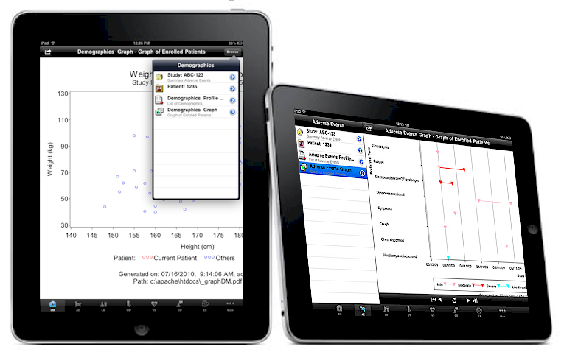
- Selecting Reports – Navigation and selecting reports by category and data domain classifications
- Display – Optimize display view of text report and graph reports on varying mobile devices
- Review – The report and graph may have multiple pages so navigational buttons and selection lists are useful for easy access
- Data Refresh – The dynamic changes of the source data required refreshing technique for live view
- Search – Applying searches on the contents of the reports can get to the data point quickly
- Sharing – Graphs and reports can be emailed as attachments as a sharing technique
In an environment where reports can mean life and death for a patient such as in the example of a clinical patient profile report, it becomes essential to have up to date reports and graphs in real time. It is also useful to deliver this information to medical monitors and clinical research associates on mobile devices since these professionals are on the go at clinical hospital sites. The delivery of patient profile reports to iPhone and iPad represents the future of SAS reporting.
Introduction
Patient profile reports existed as long as there were clinical trials studies. It is a report which captures pertinent clinical information summarized by patient and organized in a way that a medical monitor, investigator or clinical research associate can quickly access the status of patients within the study. This can be displayed in a graphical form such as a scatter plot or in a textual data listing format. It is common to have a combination of both since graphs provide a quick visual method of identify anomalies or outliers while detail data listing can help pin-point any particular data issue for any particular patient.

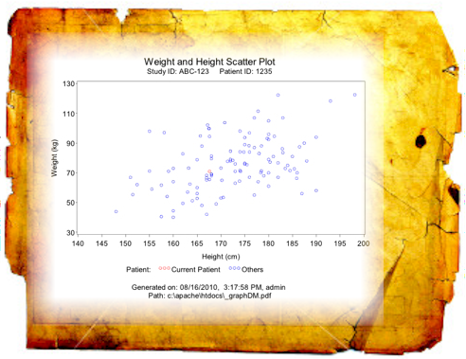
When I started working as a SAS programmer, we developed these reports in a batch environment and deliver them as physical paper organized in a binder as it is delivered to CRAs or Clinicians. Each time the safety database is updated, the batch program is re-executed to refresh the patient profile reports. These were sent out again in a new set of binders for each update. This proved to be inefficient as there was a lag in delivery due to the nature of the physical medium, not to mention that we killed a lot of trees in the process. Even though email was in use for a while, it was not until we found a secured method of sending this along with the use of ODS within SAS to produce PDF that we started to attach these reports to emails. With encryption and password authentification, we later migrated the patient profile reports to the web allowing users to view the reports through a web browser in addition to emails and printed versions. This process worked well but there was still one hurdle that remains. The users were often not at their desk with reports in hand or access to their computer. This obstacle coincides with the growth of mobile computing with the popularity of smart phones and tablet computing. This paper presents techniques and methodologies showing how these reports can be generated and sent to iPhones and iPads to mobile users. The need for the most up to date clinical information for conducting a clinical trial has never changed but the ability to access this information when mobile is going to be a game changer.
Selecting Reports
The patient profile reports can be voluminous as clinical trials progresses to Phase III with large patient populations. Selecting the particular patient and report that you want is the first step that can be crucial since it can be time consuming if the reports are not properly organized. The two interface components that are pivotal to the organization and navigation of the reports include:
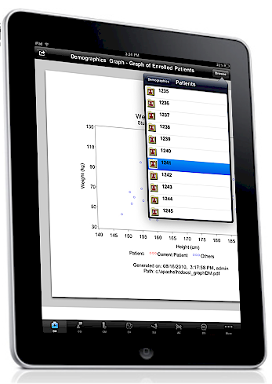
- Clinical Domain Data – A list of buttons at the bottom of the screen is common on most Apps. In this case, it is used to navigate to a specific clinical domain such as: Adverse Events or Patient Demographic information.
- Study and Patient List - Clinical data are stored in studies or protocols. Each study will have their own set of patients or subjects. This can be a lengthy list so users need to scroll through a list to select their particular patient.

Clinical domains are standardized and labeled by groups such as CDISC so this is a standard and recommended way of organizing the data. For example, reports relating to Adverse Events will be grouped within the AE domain which uses the CDISC two letter abbreviations. This patient profile report uses the main CDISC domain as displayed by their two letter names on buttons at the bottom of the screen for users to select.

The selection of study names, patient number and report names are displayed as lists. Lists on iPhone/iPad function more like a radio button on a desktop computer in that the user can only select one item at a time. However, it is displayed as a single list that the user can scroll through. It is more effective to have the name and description on the list to be short enough to fit on one line of text on the mobile device, yet descriptive enough to distinguish it from other items in the list. The iPad provides a much larger screen compared to the iPhone but the selection lists are commonly standardized to have the size of an iPhone screen size. It is important for the user to see one common list as they use the iPhone versus the iPad so the interface becomes more universally recognized regardless of device. If the text label for the selection is too long, the text needs to end in “…” indicating that the rest of text will be shown when the user drill down to the report.
These selection interface objects are common on mobile device such as an iPhone/iPad. If a user has ever used a music player such as the iPod, they are very familiar with the same controls for selecting the next or previous songs so these selection controls become second nature. The selection of information is the first step but is also a repeated step throughout the process as users may select a different patient or a different set of reports. This becomes a very common activity and by adopting Apple’s user friendly user interface, the function becomes transparent in delivering the reports.

Generating and Displaying Reports
The generation of the reports can be the same process that existed using standard SAS/Graph and ODS to generate HTML and PDF reports that has been well established before the use of mobile devices. There are many good papers and resources on this topic. An example that is shown on this paper is a demographic report comparing weight and height. These two normally correlate so if there is a data error, this graph can help identify these data issues very quickly. The sample code to generate this is shown here:

*** Generate a Demographic Weight and Height  Plot for iPhone/iPad ***;  title1 h=4 f="Arial" j=c "Weight and Height Scatter Plot";  title2 h=3 f='Arial' "Study ID: ABC-123 Patient ID: &patient";  footnote1 h=3 f='Arial' "Generated on: &curdate, &curtime, &curuser ";  footnote2 h=3 f='Arial' "Path: &curpath\&output";  proc gplot data=vs;  symbol1 i=none v=circle c=red h=2;  symbol2 i=none v=circle c=blue h=2;  plot wt*ht=curpt / haxis=axis1 vaxis=axis2  lhref=1 chref=gray;  axis1 order=(140 to 200 by 5)  label=(f='Arial' 'Height (cm)')  minor=none;  axis2 order=(30 to 140 by 20)  label=(f='Arial' a=90 'Weight (kg)')  minor=none;  run; | 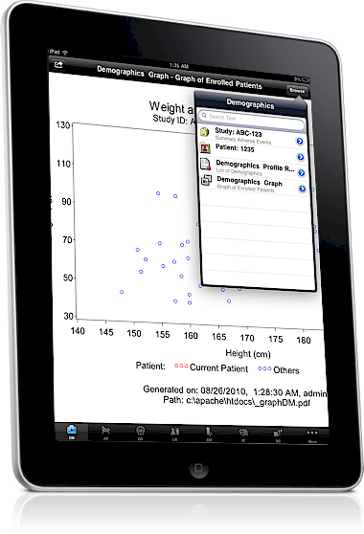
The next challenge is how to display these reports and have them optimized to be viewed on a mobile device such as an iPhone/iPad. Although the image space on an iPhone is smaller than an iPad, the multi-touch interface allows you to pinch and zoom in on a particular view within the PDF report. Other file formats such as GIF or JPEG can be used but for this implementation, the PDF file format is recommended for the following reasons.
- Zoom Resolution – When the user pinch and zoom in on an image, other file formats distort the display of text as it gets pixilated. PDF does a better job at retaining text resolution with zoom views.
- File Size – File compression from GIF and JPEG can create smaller sizes for some graphs but in general, PDF when optimized for web delivery is can keep the file size small for quick delivery and display even through slow network connection.
- Pagination – Other file formats does not really have the concept of a page. Some graphs can sometimes have multiple pages so PDF handles this well.
- Printing – When the report is shared and emailed to different users, PDF is the easiest format used for printing on most machines.

On the iPhone, the entire screen is required to display the graph or text report due to its small size. However, the larger screen size of the iPad provides the opportunity to overlay the navigational selection of reports. This is seen on the left panel within the horizontal view or popup screen on the vertical view. This layout is common for iPad Apps so the standardized interface is easily adapted by users.

 | 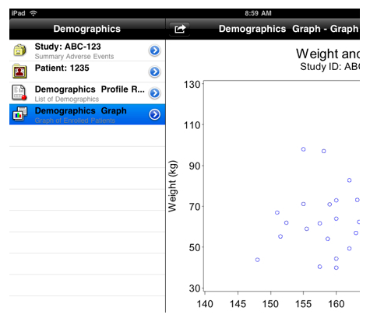
  <?xml version="1.0" encoding="UTF-8"?>
  <Studies>
  <Book id="1">
  <shortTitle>ABC-123</shortTitle>
  <longTitle></longTitle>
  <descriptionTitle>Example Study</descriptionTitle>
  <idTitle>1</idTitle>
  </Book>
  </Studies>
  <Books>
  <Patient id="1">
  <shortTitle>1235</shortTitle>
  <longTitle></longTitle> <descriptionTitle></descriptionTitle>
  <idTitle>1</idTitle>
  </Patient>
  <Patient id="2">
  <shortTitle>1236</shortTitle>
  <longTitle></longTitle>
  …
The SAS Graph output or ODS HTML output is accompanied by XML when delivered to the mobile device. This XML information contains the metadata describing the study, patient ID and other related information so the application knows how to display the information. On the SAS server, this metadata information is stored in a SAS dataset but once delivered to the mobile device; it is more efficient to have it in XML format.
The display of text reports are implemented in standard HTML with a standard stylesheets. This is then efficiently displayed on iPhone or iPad devices through Apple HTML API. There are no strict rules on text reports but in general, it is recommended that the default text font size be appropriately sized so it is optimized for viewing on the iPad or iPhone screens. The important difference between these HTML reports as compared to the ones delivered through the traditional email is that the information is dynamic. This means that as soon as a user taps on the request for the patient profile, the SAS program is submitted and the report is generated at that moment with the latest information reflecting what is currently available on the database. It is therefore recommended to have the footnote display with the date and time stamp to document this.
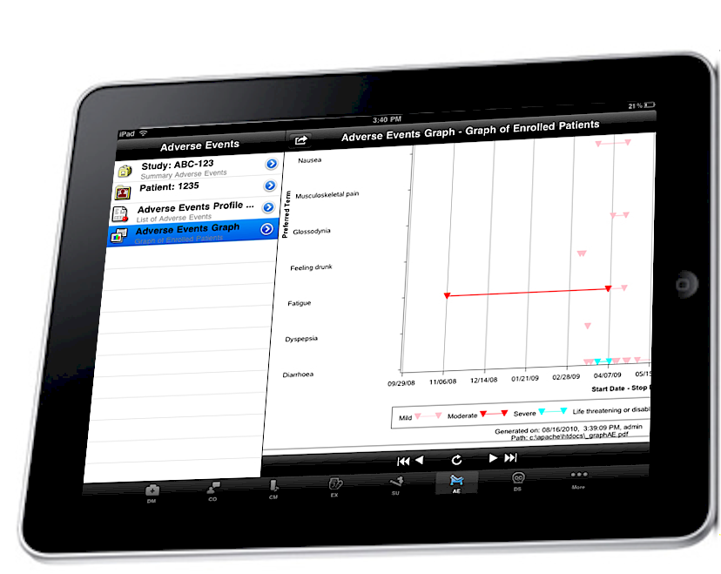

Review
The viewing of the report is significant in that it is when the users make sense out of the information and draw insights. It is during the viewing screens that navigation to specified reports and patient data are pivotal. Since patient profiles are views of the data organized by patients, the navigation of all views needs to allow the user to quickly select and navigate to any patient data within the study. This is accomplished through the use of selecting a patient ID from a selection list:

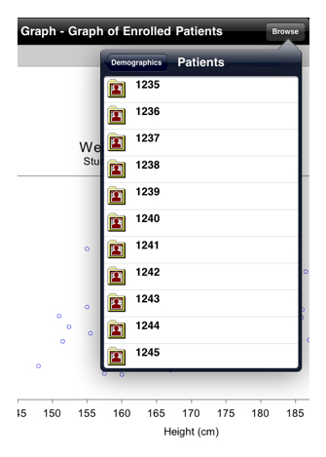 | <?xml version="1.0" encoding="UTF-8"?>  <Patients>  <Patient id="1">  <shortTitle>1235</shortTitle>  <longTitle></longTitle>  <descriptionTitle></descriptionTitle>  <idTitle>1</idTitle>  </Patient>  <Patient id="2">  <shortTitle>1236</shortTitle>  <longTitle></longTitle>  <descriptionTitle></descriptionTitle>  <idTitle>2</idTitle>  </Patient>  <Patient id="3">  <shortTitle>1237</shortTitle>  <longTitle></longTitle>  <descriptionTitle></descriptionTitle>  <idTitle>3</idTitle>  </Patient>  <Patient id="4">  <shortTitle>1238</shortTitle>  <longTitle></longTitle>  …
The selection of a particular patient is slightly different between the vertical and horizontal views since they are optimized to take advantage of the iPad screen, but the goal is the same. That is, to easily allow the user with just a couple of taps, to get to the specific data point that is requested.
Besides reviewing specific patient information, it is also sometimes useful to flip through the patient information one patient at a time. Rather than re-inventing the interface to this, a standard navigational bar that is based on many of Apple standard interfaces such as the iPod music player with next and start/end buttons are used. These universal button designs for navigation does not rely on text but uses symbols which can be used by any user regardless of language. It becomes that more intuitive.
Refresh
The data that is delivered is always the latest information that currently exist on the server. To ensure that the display is the latest, a date and time stamp appears at the bottom of each and every report.

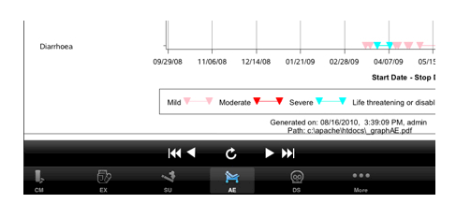

This means that at the moment the user taps on a request, a SAS program executes and generates the report. Nothing is therefore created before and sitting on the server. This dynamic nature is needed in order to deliver the most up to date information.

In the event that the user has a particular report open for an extended amount of time, they can also choose this option to refresh to get the latest report. This is done by tapping on the refresh button at the lower middle.
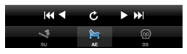

At that instant, the SAS program is re-executed to retrieve the latest information. The report is then regenerated and sent to the user’s mobile device. This is delivered through standard TCP/IP protocol over 3G or Internet networks for secured and optimized delivery.
Search
You can find the patient profile by going to the data domains and then selecting the corresponding report or you can search for it in a similar way you would do a Google search. You would simply type it a text value pertaining to the report. It will take our search criteria and apply a search on the following fields:
- Study Name and Description
- Patient Numbers
- Report name and Label
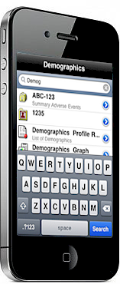
- Graph Name and Label
The search results will display in the same way you would as when you navigate to the same report. Since this information is stored in SAS datasets, a simple data step with the use of an INDEX function can accomplish this search feature.

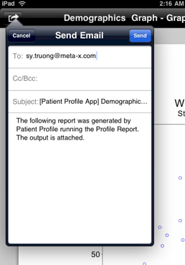
Sharing
Viewing reports on mobile devices such as the iPhone and iPad is normally a solitary task. However, in the event that a discrepancy or data issue is discovered, you can share this with team members by issuing an email. On the upper left corner of all reports, there is a button which provides the option to email the current report.

In either case of an HTML or PDF report, the current report will be attach to the email that is composed. This allow for situations where the information warrants urgent attention and this needs to be communicated to someone to take action.

Conclusion
Mobile computing has changed the landscape of how software is delivered and used. The popularity of the iPhone and now the iPad is creating a new category of tablet computers that is ahead of all other devices. Software ranging from Skype to Netflix is proving that mobile apps are augmenting if not replacing how people use applications since these applications are optimized for mobile computing and is superior to web based applications on a browser. The multi-touch interface of the iPhone has changed how all other smart phones are now used and the iPad is the answer to the net books that were portable but sacrifice function. This maturing technology is ushering in a new class of applications that meet the needs of a very specific use. This paper presents the example of a patient profile which is a SAS report that requires up to date information delivered in a mobile environment suitable for Clinical Research Associates and Medical Monitors. This illustrates how enterprise apps are meeting very specific needs and doing it well compared to the general use all purpose tools like desktop applications of web browser tools. Although the application fulfill a very specific needs such as delivering critical clinical patient report needed to conduct a clinical trial; with the abundance of apps, the mobile device such as iPhone and iPad are becoming a Swiss army knife of modern tools being used for a multitude of purposes. The Patient Profile App illustrate how SAS can be utilized to deliver applications that are maturing beyond the infant desktop and adolescence of web apps to the now mature world of mobile apps.
Contact Information
Your comments and questions are valued and encouraged. Contact the author at:
Sy Truong
MetaXceed, Inc. (MXI)
42978 Osgood Rd
Fremont, CA 94539-5627
tel: 510.979.9333
fax: 510.440.8301
E-mail: sy.truong@meta-x.com
Web: www.meta-x.com

SAS and all other SAS Institute Inc. product or service names are registered trademarks or trademarks of SAS Institute Inc. in the USA and other countries. ® indicates USA registration.
BI Flash™ are trademarks of Meta-Xceed, Inc. (MXI).
iPhone® and iPad® are trademarks of Apple Computers.
Other brand and product names are trademarks of their respective companies.

