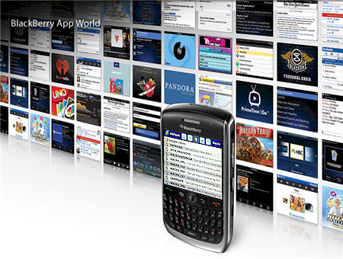
SAS® Data and Stored Process on BlackBerry®
Sy Truong, Meta-Xceed, Inc., Fremont, CA
ABSTRACT
In the competitive smart phone environment, RIM BlackBerry® remains the leading smart phone worldwide changing how we use mobile computing. Although both the iPhone and Android have been making the headlines, BlackBerry is quietly growing in the area of mobile applications with its introduction of App World 2.0 and BlackBerry OS 5.0. All major websites such as Google, eBay, and Amazon have their services available as an “App” rather than requiring the user to launch a web browser. These BlackBerry applications add an efficient use of local mobile device resources that enhance the user mobile experience; while leveraging traditional client server computing features that are similar to that of a web browser. Models such as BlackBerry Curve, Tour, Storm, Pearl, and Bold all provide feature sets such as GPS tracking, voice communication, digital video recorder, and multitudes of other functionality that raise the bar beyond web 2.0. SAS® has been an analytical business intelligence powerhouse for many years; yet it is a relative late comer to this mobile computing revolution. This paper demonstrates how a SAS dataset can be viewed on a BlackBerry. It also takes a sample SAS stored process, or a traditional SAS macro, and its parameters which can be presented through a GUI for user selection on a BlackBerry. It then executes the program or SAS stored process with the output results displayed on the BlackBerry for review. Imagine how you can access the most up to date and dynamic business information delivered directly to you anywhere where there is a cellular signal. At last, business analytics is no longer placed behind walls guarded by legions of power users, but rather it will be unleashed to users on the go!

Introduction
Mobile computing with the popularity of smart phones is reaching a tipping point that is going to have profound effect on how we access and work with information. The BlackBerry Curve and Bold accompanied by the App World has increased the cadence as competitors such as Apple iPhone and Google Android is competing. The industry is reaching a point of critical mass that can no longer be ignored since the BlackBerry and related devices have become a powerful force in many corporate environments. The App World makes it easy for users to download applications with its upgrade to version 2.0. It is becoming a ubiquitous mobile computing device going beyond just being a phone and therefore blurring the classification of a netbook and augmenting laptops. It can no longer be berated as just a cell phone but now considered a serious computing device.

When I first started using SAS on mainframe computers, I noticed a similar attitude that system administrators and SAS analysts had towards the IBM PC. These small desktop computers along with its burgeoning Windows operating system was considered a toy and therefore could never really run serious business applications crunching large data with powerful analytics. The closed minded mindset that PCs were just toys was analogous to how skeptics today view the BlackBerry and other mobile devices. Those same managers closed their eyes to the many uses of the diverse set of applications that run on PCs. They began to see its usefulness when the PCs were connected to the Internet which changed everything and pushed mainframe computing into relics of the past. The many applications that are being developed for the BlackBerry demonstrate that there are many killer apps that can be game changers which are analogous to its predecessor in the PC hey day.

There have been many wars waged within the computer industry ranging from hardware to browsers. What it all boils down to when it comes to the user’s experience is the application. In the smart phone war, the App World has demonstrated its ability to deliver applications. In many instances, the BlackBerry application is competing and replacing mobile web through a web browser. Users are no longer going through a browser but rather gravitating towards a new access point of a variety of distinct applications. This is a fundamental shift that will seriously alter cloud computing and related Internet services. To put it bluntly, “It is the App Stupid”.

It is not too late for SAS analysts who are glued to their laptops, desktops and servers to benefit from the mobile revolution. This paper will elaborate on a few of the following areas which debunk the notion of BlackBerry as a mere toy and show that it can deliver serious business applications such as SAS in ways that were not possible before. This includes:
- System Architecture – How a BlackBerry accesses SAS data and macros
- Application Servers – SAS as an application server for BlackBerry applications
- Secure Users – Authenticating users and securing access to data
- Macro Parameters – It’s no longer limited to check boxes and radio buttons
- Viewing Data – Viewing SAS data in a mobile smart phone

This paper will elaborate on these concepts through the example illustrated through BI Flash™ software which is a combination of SAS programs and a BlackBerry App. It will demonstrate how real practical and useful SAS macros or stored process can deliver dynamic business critical analytics to mobile users. We are about to enter into a new era of computing, leaving behind traditional PCs and web 2.0. This paper paves a new path into how SAS can boldly step into this dynamic world of mobile computing.

System Architecture
The delivery of SAS data and reports to the BlackBerry requires a different architecture as compared to traditional client server systems. This is similar to web applications in how it delivers information to a browser, but in this case, the BlackBerry application replaces the browser. The diagram below shows the components of this computing architecture including: the BlackBerry application, a web server and the BI Flash application server.
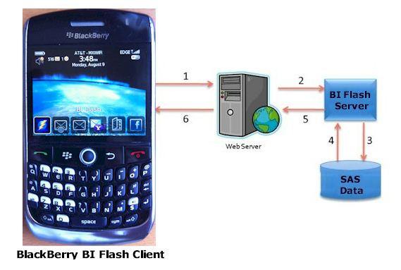
In this example, the BlackBerry application communicates through standard TCP/IP protocol to a web server. The web server then communicates to an application server which is actually a SAS session processing SAS programs and data. The output resulting from the SAS program is then delivered back to the BlackBerry in a similar way a web browser would access web pages stored on a web server. The distinction however is that the BlackBerry application is not a web browser and the SAS session running on the server is more dynamic compared to a static HTML page. The SAS data, macro programs and stored processes that are requested may be simple and standard yet facilitating the communication takes a little more effort. The request from the BlackBerry application and the delivery of information from the server is handled by BI Flash. This makes the experience more dynamic and delivers the full power of SAS on the server to the BlackBerry. The following steps are taken by the user in order to access SAS information on the BlackBerry.


Step 1 – Download BlackBerry Application
One of the most unique and successful aspects of the BlackBerry is how users can easily download a BlackBerry App directly from the RIM App Store. This is a user friendly way of searching for and downloading applications to your BlackBerry. In this case, you can search for and download the “BI Flash” application which is referred to as the client component which enables the communication between the BlackBerry and the SAS server.

Step 2 – BI Flash Application ServEr
More details on this step will be explained in the “Application Server” section but an administrator would manage and utilize the BI Flash server. This server functions as a listener waiting for a request from the BlackBerry. Upon receiving a request, it would process this similar to how you would submit SAS programs from display manager. The server would generate a SAS log and output results in XML which is then sent back to the BlackBerry to be viewed.

Step 3 – COnnect BlackBerry to Application Server
Most BlackBerry applications have configuration settings. This allows for users to easily configure settings once during setup and then use the application without further changes unless future configuration changes are needed. In order for the BI Flash BlackBerry app to access SAS, the user would need to configure the following:
- Host Name – This the name of the server or an IP address of the SAS server
- User Name – A valid user name that has been defined on the server needed during authentification
- Password – A user defined password to secure access

There may be other configuration options which will set the default behavior of the application but the parameters above show the minimum requirement in order to connect to a SAS server.

Step 4 – run Application
The final step taken by the user to access SAS data is to execute the SAS macros from the BlackBerry. This request is initiated from the BlackBerry app and sent directly to the server along with the user selected options. The results are then returned to the BlackBerry displaying the most updated information on the server.

The system architecture in this example is rather simple compared to other systems that require multiple layers of middleware. This is similar to the SAS/IntrNet where users are on a web browser accessing SAS data and programs on the server through the broker and SAS application server. The difference however is that the client is not a browser, but rather a dynamic BlackBerry application which can fully take advantage of the user interface and processing of the BlackBerry environment.

Application Servers
An application “server” in this context is essentially a SAS session waiting to receive requests from the user. Once a request is received, it would then execute the specified SAS scripts and then deliver its output back to the user. One application server can serve many users at once. The server is able to do this when queuing up multiple requests and then executes it one at a time. Each application server is assigned a set of SAS libraries to easily access predefined data and related SAS programs or stored processes.
The SAS program that is requested by the user also resides on the server as defined by a library. This can be pre-assigned similar to how you can assign a LIBNAME or FILENAME in an AUTOEXEC file used during an execution of a SAS program. The assignment of these libraries is established when the application server is setup.
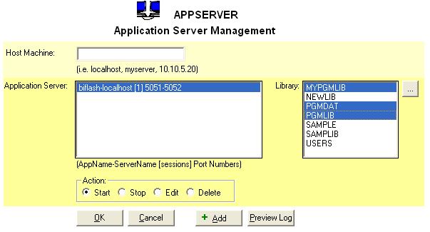
Each application server communicates to its corresponding BlackBerry application through its own assigned TCP Socket port. This ensures that there is no collision between multiple applications for optimal performance. If needed, it is optional to increase the number of ports to handle additional requests. In this case, a separate SAS session is started on the server running simultaneously to enable greater bandwidth.

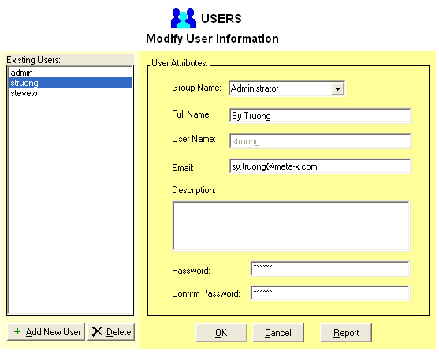
Secure Users
There are two distinct roles that users play to enable the delivery of SAS data and programs to the BlackBerry including an administrator and end-user. The administrator is usually the SAS analyst or statistician that developed and manages the data, SAS program, or stored process on the server. The BlackBerry user receives the reports and data onto their BlackBerry. Before a user can access SAS reports and data, the following steps are taken to ensure proper security.

Step 1 – Account Setup
An account is set up on the server with the proper credentials in order to identify and authorize the user. The key attributes needed to authenticate the user include a unique user ID and user defined password.

Step 2 – User Privileges
By default, the user only has access to a set of sample SAS macro programs, stored processes and datasets that come with the system. In order to deliver real information, additional SAS macros and data need to be registered and have read and execute permissions granted.
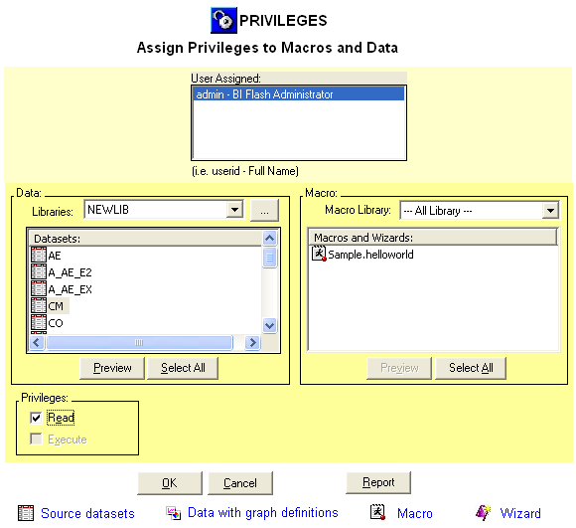
The permissions model is simple compared to an operating system layer of security since there are only two types of privileges needed including “read” permission for SAS data and “execute” permission for SAS macros. It is implied that if the user can execute a macro that they also have read permission to the macro and its related output.

Step 3 – Login and View
Once the administrator applies the correct permissions, the BlackBerry user can see the programs and stored processes on their selection lists. They can then view the data in a viewer or execute the macro and view its resulting output report.

It is useful to have users access the data to which they have been granted access. The management of each program and data however adds administrative overhead. In this example, the effort is kept to a minimum so that both the administrator and BlackBerry end-user can get to the information that is needed in an efficient manner.

All of the user permissions are handled on the server and stored centrally within a SAS dataset. Each dataset and SAS macro is managed centrally on the server within a dataset with each item assigned to a unique identifier. The dataset structure that stores this is shown here.

Variable | Type | Label
Objid | Num | Object ID
Libname | Char | Library Name
Items | Char | Items
Type | Char | Object Type
Userinter | Char | User Interaction Name
Datetime | Num | Date Time of User Interaction
Privileges | Char | Privileges
In this case, the privileges variable stores a simple value “read” or “write”. This dataset is then used to document and manage all privileges associated with macros and data stored in the system.

Macro Parameters
In the traditional batch environment, users specify the options for a macro by typing the selected values in a SAS program script when invoking a macro. The entered values would then be processed by the macro by inserting them into the specified parameter in the code. An example macro call is:

*** Generate Report of data by specific subset ***;
%dataview (indata=mylib.demog,
sortby = subjid startdt,
reptitle = Demographic data sorted by subject ID and start date);
In this example, there are three parameters including: INDATA, SORTBY, and REPTITLE. The BlackBerry application captures these parameters with a user friendly interface as compared to having the user write a SAS macro call. In this case, the BlackBerry user selects the values for the macro parameters through the interface of the BlackBerry device. The user would therefore access and execute the %dataview macro by simply performing the following steps.

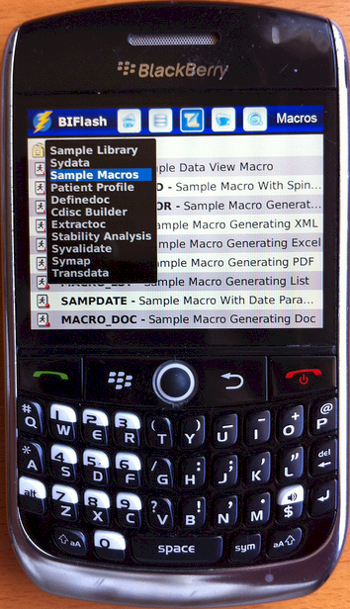
Step 1 – Selecting Macro
The user would navigate to the macro section by clicking on the macro button on the navigational bar at the bottom. This brings the user to a list of all the SAS program macros that the user has privileges to in the current library.
The user then navigates through the libraries by clicking on the library choice as shown in the current “PGMDAT” example. In this case, they would click on the “%DATAVIEW Macro” to drill down to its parameters.

Step 2 – Selecting macro parameters
Upon selecting of the %datataview macro, all the macro parameters will be presented with standard BlackBerry user interface elements. Each parameter will be listed as in the order in which it is defined.

In the traditional macro approach, the user would input the values of the parameter by typing the text upon a SAS script file according to the named parameters. This is difficult for users since they are not familiar with the correct spelling of the library or dataset name. This commonly leads to erroneous entries and errors in the macro execution. On the other hand, the BlackBerry interface is much more user friendly. In this example, three distinct entry types are displayed.
- Input Data – The input data parameter uses a standard SAS two level dot notation which is LIBNAME.DATASET. In this example, it is “mylib.demog” which refers to a library “MYLIB” and the dataset DEMOG. The user can edit this as open text or in addition, there is the option of drilling down to a list for the selection of libraries and datasets in selection.
- Sort Variables – The sort variables is a standard multiple option selection list. There are several different types of selection lists. In this case, a simplified multiple selection list is presented as an example.
- Report Title – The report title requires a standard text entry field which the user can type any text value with the aid of an onscreen keyboard.

There are many other types of controllers which macro parameters can be associated with to make the user entry more intuitive.
Some of the graphical user interface elements are similar to those found on desktop windows applications. The text entry and check list is similar to a text entry or list box on desktop applications. They only differ in their layout so it is easy for users on a smaller screen. However, some user interface elements diverge from the desktop interface to fully take advantage of the smaller screen of a BlackBerry. The author of the macro would configure their macros and select which controller is best suited for each parameter. Default list of values will be displayed based on values of a dataset or the SAS system views such as SASHELP.VSLIB for a list of available libraries. Once the macro author configures this on the server, the user can benefit from having a user friendly method of selecting and executing the macros.
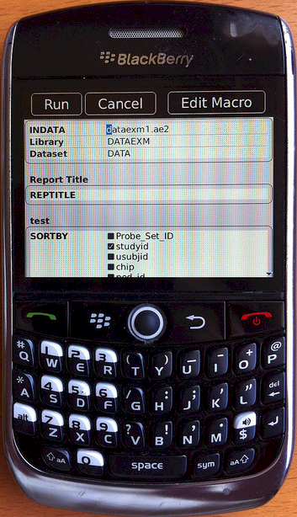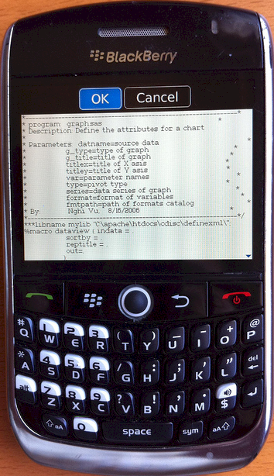
Upon completion of parameter selection, the user would click on the “Run” button on the upper right to have it execute on the server. Depending on the macro ODS option; the result can be generated in HTML, PDF, RTF or many other file formats. The output viewer supports all of these formats which allow users to navigate to and zoom in on any particular output data point.
If the user finds the particular report important to share, they can click on the upper right corner send button and compose an email. In this case, the output will be attached to the email so the recipient can receive the full output along with the email describing the meaning of the report. For large output report files, the email is handled on the server so the attached report does not have to be downloaded to the BlackBerry and then sent to the recipient.
The added ability to share the information through email extends the collaboration effort which is crucial in projects that require large teams. This provides capabilities that were once only available to laptops for mobile users. The ability to do this on the BlackBerry will provide important data and analytics components to a larger group of users.

Viewing Data
SAS macros are very effective at allowing users to perform analysis by dynamically requesting for reports or views of the data. However, there are times when all the user needs to view is the actual raw data. On the Windows desktop environment, you would use the SAS data viewer. However, the BlackBerry has different capabilities such as magnify tool to zoom on data views. These additional features can be used to view the data more effectively. The following illustrates the steps taken to view SAS data on the BlackBerry.

Step 1 – Selecting Library
SAS datasets are stored in libraries which point to physical folders on the server. This is also refereed to as SAS LIBNAMEs. The main datasets screen on the BlackBerry contains the latest list of datasets. The first item on this list is the library that is currently being viewed.

By clicking on the library right arrow labeled “datlib”, the user drills down to a list of libraries that the user has permissions to. The current selected library is identified with a check mark and colored with standard selected blue tint. The user can then select any other library by clicking on the desired library.

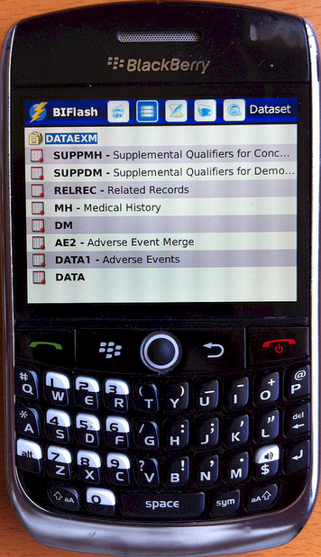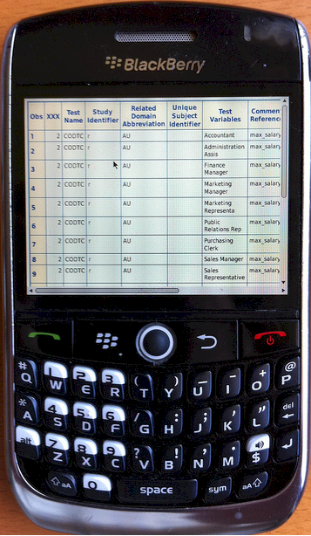

Step 2 – Select Data
The main dataset list displays all dataset names along with the associated label available within the selected library. This can be efficiently scrolled through by using the vertical swipe action which is standard for the BlackBerry interface. The text size and layout of the dataset list is optimized for the user selection within the BlackBerry interface.

Step 3 – View Data
Upon the specific data selection, a data viewer is presented with all the rows of the data. Chunks of the data of delivered to the BlackBerry which can be configured. In this example, 20 rows at a time are displayed. The user can then jump to specific blocks of data using the next and previous buttons or the horizontal slider control to navigate to specific chunks of the data.

In the event that the data table being viewed is very large, it is broken down to smaller chunks to optimize download and viewing experience. In this example, it is shown in small chunks of 20 rows as indicated at the bottom navigation bar of “1-20”. This represents the display of the first 20 rows of data in the current dataset.

The interface has been modeled after other existing standard BlackBerry applications such as iPod music player which has standard buttons and layout. RIM has devoted extensive research into developing a user interface that is user friendly for the mobile device optimizing object size and placement for optimal functionality. Many of the same user elements are implemented in this data viewer leveraging upon RIM’s standard to enhance the user’s experience.

The code and algorithm logic that goes into developing the SAS application server and BlackBerry client application is extensive. This section will select one section in step 1 on libraries and describe how this is accomplished. The following steps are applied to present the list of library screens.

Step 1 – Capture Libraries
A SAS program is initiated on the server to capture all libraries available. It is then compared to the user permissions before the final list is sent to the client BlackBerry. The following example code is used to capture this:
do while(fetchobs(dsid,cnt) = 0);
libname1 = upcase(getvarc(dsid,varnum(dsid,'libname')));
if libname1 not in ('WORK','SASUSER','SASHELP','SASMSG','MAPS',
'PGMLIB','_MXI','SERLIB','DATLIB','USERS') then do;
if searchc(liblst, libname1, 1, 1, 'Y') = 0 then do;
rc = insertc(liblst,libname1,-1);
path = lowcase(getvarc(dsid, varnum(dsid, 'libpath')));
idx = index(path, '\');
path = substr(path, idx);
path = tranwrd(path, '\', '/');
rc = insertc(pathlst, path, -1);
end;
end;
cnt = cnt + 1;
end;
dsid = close(dsid);

In this case, it captures libraries from the SASHELP.VSLIB view and inserts its findings into a list to be used later.

Step 2 – Subset user Privileges
A SAS program is initiated on the server to capture all libraries available. It is compared to the user permissions access control list. BI Flash stores all the user permissions as described in the permission section above.

Step 3 – XML Library List

Once the final list of libraries is captured, an XML file is created capturing all the libraries as shown here.

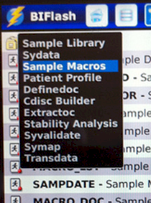
<Libraries>

<Library id="1">
<shortTitle>Sample Library</shortTitle>
<longTitle></longTitle>
<descriptionTitle>/myserv/lib1</descriptionTitle>
</Library>
<Library id="2">
<shortTitle>Sydata</shortTitle>
<longTitle></longTitle>
<descriptionTitle>/myserv/testlib</descriptionTitle>
</Library>
<Library id="3">
<shortTitle>Sample Macros</shortTitle>
<longTitle></longTitle>
<descriptionTitle>/myserv/testlib</descriptionTitle>
</Library>
...
</Libraries>

This is information is then delivered to the BlackBerry via a web server used to for the user selection.

Conclusion
The distribution of products and services has radically changed in recent years as it becomes more efficient for companies like Google, eBay and Amazon to take advantage of efficiencies of Internet distribution. Rather than concentrating on the top few blockbuster products, these companies are finding that the many niche products such as specialized advertisement on Google and esoteric books on Amazon add up to be just as significant in total sales as their super sellers. The cost for them to distribute the large array of solutions has become profitable when efficiently delivered across the internet as compared to shrink wrap boxes sold in stores. This shift in the market is also taking shape in how software is being delivered. It is now extending into the App World as a new way in distributing more specialized software within a hyper efficient distribution model. The mobile computing platform such as the BlackBerry has become a potent platform to deliver useful and specialized analytics software to users. At the current moment, however, there is very little in this space for business intelligence applications on the App World and none for SAS. It is unquestionable that SAS can deliver sophisticated business intelligence information by delivering SAS macros coupled with its programming language to deliver tremendous analytical power. In the past, the access to these tools has been limited to power users who can write SAS code or utilize BI tools on SAS servers. This paper has presented examples where the power of traditional SAS programs and stored processes can be delivered to users on the BlackBerry. This bridges the gap by delivering endless possible aggregate views of the data to users without requiring them to understand SAS programming or the details of the SAS system. This will truly liberate business intelligence to be accessed by any user allowing them to get the latest information anytime directly from a device in their pocket.

Contact Information
Your comments and questions are valued and encouraged. Contact the author at:

Sy Truong
MetaXceed, Inc. (MXI)
42978 Osgood Rd
Fremont, CA 94539-5627
tel: 510.979.9333
fax: 510.440.8301
E-mail: sy.truong@meta-x.com
Web: www.meta-x.com

SAS® and all other SAS Institute Inc. product or service names are registered trademarks or trademarks of SAS Institute Inc. in the USA and other countries. ® indicates USA registration.
BI Flash™ are trademarks of Meta-Xceed, Inc. (MXI).
BlackBerry® are trademarks of RIM.
Other brand and product names are trademarks of their respective companies.

